HTML Notes
- Document Setup
  - <!DOCTYPE html> → Declares HTML5 Example: <!DOCTYPE html>
  - <html> ... </html> → Root element
Example: <html lang="en"> ... </html>
  - <head> ... </head> → Metadata, title, links Example: <head><title>My Page</title></head>
  - <body> ... </body> → Visible content
Example: <body><p>Hello World!</p></body>

Text & Structure
  - <h1> → Heading level 1
Example: <h1>Main Title</h1>
  - <p> → Paragraph
Example: <p>This is a paragraph.</p>
  - <br> → Line break
Example: Line one<br>Line two
  - <hr> → Horizontal line
Example: <hr>
  - <em> → Emphasis (italic)
Example: <em>Important word</em>
  - <strong> → Strong importance (bold)
Example: <strong>Warning!</strong>

Links & Media
  - <a href="URL"> → Hyperlink
Example: <a href="https://example.com">Visit Site</a>
  - <img src="path" alt="text"> → Image
Example: <img src="cat.jpg" alt="Cute cat">
  - <iframe src="URL"> → Embed another page
Example: <iframe src="https://example.com"></iframe>

Lists
  - <ul> → Unordered list
Example: <ul><li>Apple</li><li>Banana</li></ul>
  - <ol> → Ordered list
Example: <ol><li>First</li><li>Second</li></ol>
  - <dl> → Description list
Example: <dl><dt>HTML</dt><dd>Markup language</dd></dl>

Tables
  - <table> → Table container
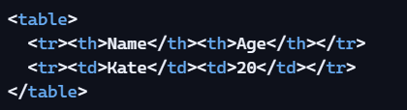
Example:
Attributes: colspan, rowspan
Example: <td colspan="2">Merged Cell</td>

Forms
  - <form> → Form container
Example: <form action="/submit" method="POST"> ... </form>
  - <input type="text"> → Text field
Example: <input type="text" placeholder="Enter name">
  - <input type="radio"> → Radio button
Example: <input type="radio" name="gender" value="male">
  - <input type="checkbox"> → Checkbox
Example: <input type="checkbox" checked>
  - <select> → Dropdown
Example: <select><option>Option 1</option></select>
  - <button> → Button
Example: <button type="submit">Send</button>
_________________________________________
CSS Notes
- Selectors
  - element { } → Targets HTML element
Example: p { color: blue; }
  - .class { } → Targets class
Example: .note { font-size: 14px; }
  - #id { } → Targets ID
Example: #header { background: gray; }
  - [attribute] { } → Attribute selector
Example: input[type="text"] { border: 1px solid black; }
  - :hover → Pseudo-class
Example: a:hover { color: red; }
  - ::before → Pseudo-element Example: p::before { content: "★ "; }

Text Styling
  - font-family → Typeface
Example: body { font-family: Arial, sans-serif; }
  - font-size → Size
Example: h1 { font-size: 24px; }
  - font-weight → Thickness
Example: strong { font-weight: 800; }
  - color → Text color
Example: p { color: green; }
  - text-align → Alignment
Example: h2 { text-align: center; }

Box Model
  - width, height → Size
Example: div { width: 200px; height: 100px; }
  - margin → Space outside
Example: p { margin: 20px; }
  - padding → Space inside
Example: div { padding: 10px; }
  - border → Border style
Example: img { border: 2px solid black; }
  - background-color → Background
Example: body { background-color: #f9f9f9; }

Layout
  - display → Block/inline/flex/grid
Example: span { display: inline-block; }
  - float → Left/right
Example: img { float: right; }
  - position → Static/relative/absolute/fixed
Example: div { position: absolute; top: 10px; left: 20px; }
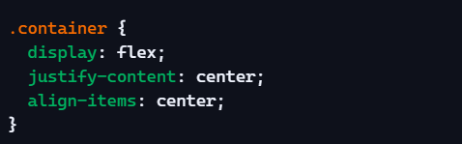
Flexbox Example:

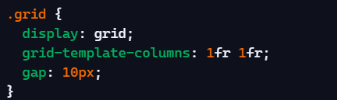
Grid Example:

Responsive Design
  - Viewport meta tag
Example: <meta name="viewport" content="width=device-width, initial-scale=1">
  - Media query
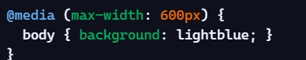
Example:

Effects
  - transform → Rotate/scale/translate
Example: div { transform: rotate(45deg); }
  - transition → Smooth change
Example: button { transition: background 0.3s ease; }
  - animation → Keyframes
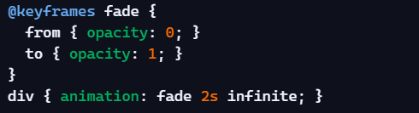
Example:
  - filter → Image effects
Example: img { filter: grayscale(100%); }

